|  |
| --- |
| A Cutting-Edge Approach for MRI Brain Tumor Deduction Using CNN-LSTM  Dr.A.Shenbagarajan ,Inish Raj B, Bharath D  Associate Professor, Department of Artificial Intelligence and Data Science  Mepco Schlenk Engineering College  Sivakasi, India  shenbagarajan@mepcoeng.ac.in  Student, Department of Artificial Intelligence and Data Science  Mepco Schlenk Engineering College  Sivakasi, India  inishraj.b.s003_ai@mepcoeng.ac.in  Student, Department of Artificial Intelligence and Data Science  Mepco Schlenk Engineering College  Sivakasi, India  sreelathadurai7173 _ai@mepcoeng.ac.in  Abstract— Brain tumors pose an enormous medical challenge, necessitating early identification and treatment in order to improve patient outcomes. Recent breakthroughs in the field of medical imaging have seen the implementation of state-of-the-art deep learning algorithms, notably Convolutional Neural Networks (CNN) and Long Short-Term Memory (LSTM) models, for the early diagnosis and classification of brain cancers. Early diagnosis is crucial for timely therapy and lifestyle adjustments in order to avoid the tumor from progressing to a more critical stage.Beyond improving the quality of treatment, early detection of brain tumors enables patients and their families to plan for subsequent care, access the necessary support, and consider participation in clinical trials for alternative therapies, offering them a ray of hope. Additionally, early detection and classification can aid health care providers in determining whether the tumor is malignant or harmless and precisely locating it within the brain.To determine the presence and severity of a brain tumor, this investigation capitalizes on pre-trained models that analyze magnetic resonance imaging (MRI) data. Popular neural network architectures, including VGG16, EfficientNet, and Inceptionv3, are applied for classification and performance assessment. The merging of CNN and LSTM models in this setting shows potential for transforming brain tumor diagnosis and therapy, thereby increasing patient care and medical outcomes. This strategy has the potential to make a big influence on the healthcare business and the lives of patients and the people they love.  Keywords- Brain Tumor disease, Neural Networks, Deep Learning, Pretrained Models, Transfer Learning, MRI |

# **INTRODUCTION**

The human brain, a marvel of intricacy, manages vital biological activities, from heartbeat and respiration to blood flow regulation. Shifting our focus to brain tumor detection, we discover that revolutionary technologies like Convolutional Neural Networks (CNN) and Long Short-Term Memory (LSTM) models shows enormous potential in this domain. Early diagnosis is pivotal, as it enables timely medical attention and necessary adjustments to lifestyles, potentially averting the progression of brain tumors to more critical periods.In the early phases, brain tumor cases could appear as mild cognitive difficulties or subtle impairment of memory, akin to having trouble recognizing the location of everyday items. Cognitive processes begin to decline more, impacting intimate data recall, like phone numbers or locations, and the remembering of past experiences and recollections. As disease advances, individuals more and more rely on caretaker support in performing their everyday responsibilities, with caregiving turning into more prominent in the final stages of the disease.the context of advanced stages, folks lose awareness of their environment and control, and their mental abilities significantly deteriorate. Their communication gets broken down and they become more prone to illnesses. Brain tumors present an enormous concern, influencing humans of various age groups, and the timely detection and medical management of these tumors are crucial for improved results for patients.Deep learning methodologies, including CNN and LSTM models, play a critical part in brain tumor detection, making use of models that were previously trained and medical imaging data. Recognized neural network architectures, such as VGG16, EfficientNet, and Inceptionv3, are essential in the classifying and performance evaluation of brain tumor patients. The merging of CNN and LSTM models holds enormous potential for changing brain tumor diagnosis and therapy, ultimately boosting care for patients and medical outcomes. This branch of research is crucial in the goal of early identification and intervention for brain cancers, as seen in Figure 1, which illustrates the contrasts between a brain in good condition and one impacted by a tumor. The implementation of Convolutional Neural Networks (CNN) and Long Short-Term Memory (LSTM) models in MRI brain tumor diagnosis involves problems such as data quality, dataset size, and model interpretability. Ensuring high-quality MRI images, getting big and well-labeled datasets, as well as rendering these deep learning algorithms more interpretable in a therapeutic environment are ongoing problems. On the clinical front, this technique provides numerous applications, including early tumor diagnosis, precise tumor categorization, real-time monitoring of tumor development and response to treatment, and the generation of individualized treatment plans that utilize evolving patient-specific data. These applications hold the possibility of improved quality of life for patients in the recognition and treatment of cancers of the brain.

# **LITERATURE SURVEY**

The environment of MRI-based brain tumor categorization is affected by numerous approaches and models, as demonstrated in several research publications. Aly and Alotaibi (2023) offer EMU-NET, a modified U-Net architecture, to perform automatic categorization and segmentation of brain tumors [1]. Gajula and Rajesh (2023) present an outcome analysis utilizing Resnet50, which and a deep leftover U-Net for brain cancer MRI categorization and detection [2]. Mahajan and Chavan (2023) focus on multiclass categorization using CNN over brain tumor detection from MRI images [3]. Mohan and Samudrala (2023) propose the use of U-NETWORK CNN models as tools for MRI brain malignancies detection and classification[4,5].   
  
Nayak et al. (2022) examine brain tumor categorization using Dense Efficient-Net [6]. Pravallika and Baskar (2022) compare VGG16 and SVM for better performance in information processing-based brain tumor classification [7]. Shanjida, Islam, and Mohiuddin (2022) suggest a hybrid CNN-KNN technique for MRI-based brain tumor identification and classification [8]. Soumik and Hossain (2020) apply Inception Systems for transferring learning-based brain tumor categorization [9, 10]. Sowrirajan, Balasubramanian, and Raj (2023) provide an amalgamated VGG16-NADE model for MRI-based brain tumor categorization [11]. Yahya Rbat, Aljobouri, and Hasan (2022) recommend a comprehensive CNN technique for MRI brain tumorclassification[12].  
  
Asodekar and Gore (2019) examine brain tumor identification using geometry analysis of MRI images [13]. C. N. (2020) develops a chaotic biological geography rider-based neural network system for brain tumor categorization [14]. Montaha et al. (2022) present a hybrid Timedistributed-CNN-LSTM technique for classifying brain cancers on 3D MRI data [15]. T S, C. et al. (2023) have contributed to computerized brain tumor detection and placement using U-Net architecture segmented and CNN-LSTM categorization [16]. Jindal et al. (2022) provide deep learning-based brain malignant tumor classification utilizing MRI image segmentation helped by bias domain rectification and histogram equalization [18]. Lakhanpal (2022) gives a complete overview of brain tumor the process of segmentation classification, and detection utilizing MRI scans [19]. Tummala (2022) introduces brain tumor categorization on MRI employing Vision Transformer ensembling [20].

# **DATA SET**

The data was acquired from the website operated by Kaggle. Approximately 6400 MRI (The magnetic Magnetic Imaging) images are accessible, and they are categorized into four distinct groups: glioma, meningioma, no tumor, and pituitary. 20% of the photos are utilized for evaluation, whereas 80% are utilized to instruct the model. So assuming that there is no difference when comparing predictions when both models have distinct forms of inputs, the data sets should have the same type of distribution. Each picture is 224 × 224 in size. The four different types of AD which are glioma, meningioma, no tumor and pituitary are represented in figure 2.

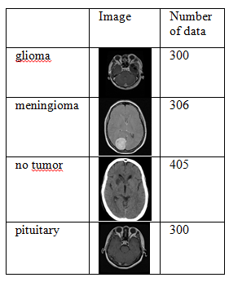

Figure 1. Class labels of brain MRI images

# **PROPOSED METHODOLOGY**

Deep learning is designed to understand an ordered set of notions, and as a consequence, it is believed to understand features at three separate levels: a minimum, intermediary, and bigger. Neural networks can manage ever-larger data because of their versatility. It is useful for generalizing previously unseen data because of its various levels. Different methods leverage the underlying comprehension of neural networks along with various datasets for testing and training purposes. Deep learning also involves layers that allow algorithms to comprehend and evaluate input, much way people have sensory neurons. These successive layers gain knowledge by examining the data presented to be analyzed as input then computing the input as they proceed through the layers. The function known as activation is then applied after traversing the final layer, providing the simulation the predicted result. Through doing this, training precision is boosted.   
  
The deep learning methods that fall within the domain of multilayer neural networks are primarily utilized for identifying and categorizing problems. They were created to autonomously and adaptively acquire spatial feature hierarchy from input datasets. Overall, the unique design of CNNs has proved to be exceptionally useful for a number of applications involving computer vision, and it continue to be a significant part of many of the newest and most advanced models in the field. For the objective of detecting AD early, the suggested model combines learning via transfer with the already trained VGG16, EfficientNet, and Inceptionv3 algorithms. These more complicated CNN structures are formed utilizing the core CNN building components.  
  
Transferring knowledge is a valuable method since it saves valuable time and creates precise models. The technique of transfer learning does not start the process of learning from scratch, instead it builds on existing patterns that were previously recognized in a dataset. In reality, models with prior training are utilized to imitate transfer learning. As a result of the enormous computational expense of training these kinds of models, many people adopt models that have been obtained directly from studies in academia. In the third picture, the transfer training model is depicted.

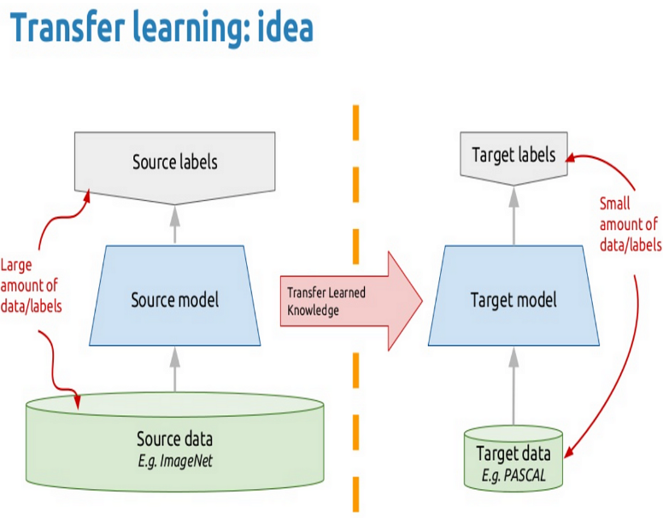

Figure 2. Transfer Learning model

The preliminary processing data is a common first step in the deep learn approach to prepare raw input in a way that the model can interpret or accept. As an instance, you can alter the picture being input to fit the size of a picture's input layer. Data preparation can also be applied to eliminate abnormalities which might prejudice the network or increase desired features. Consider normalizing or eliminating noise from the acquired data. To preliminary processing the dataset, several models adopt smoothening and rescaling techniques.   
  
To boost the quantity of pictures, the suggested model utilizes data augmentation. "Data supplementation" is the process of considerably raising the quantity of information by adding additional points of information from the existing data. This comprises upgrading data sets by modifying the information and applying deep learning methods to produce fresh points of data in the initial data's subspace. It improves the deep training models' accuracy. Few augmented photographs are exhibited infigure4.

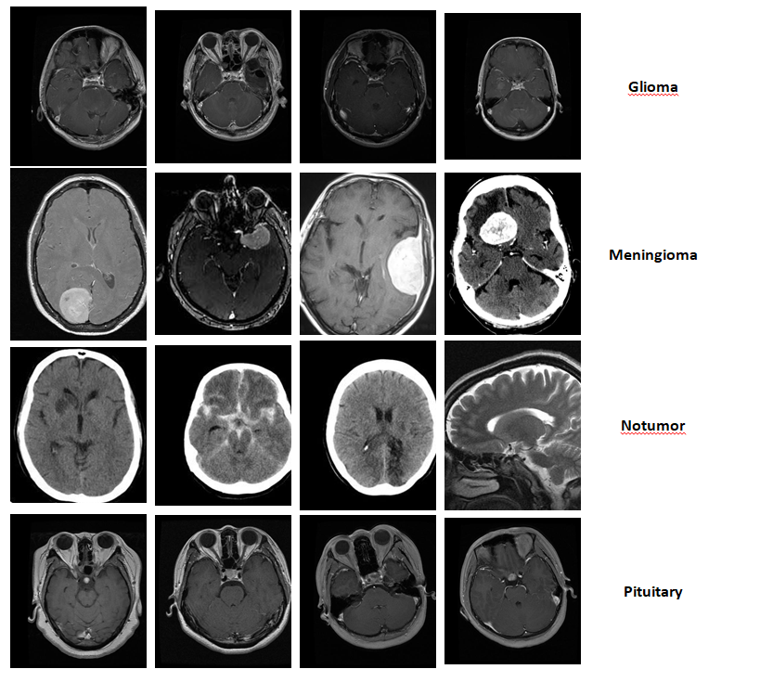

Figure 3. Augmentation of images

# **PRETRAINED MODELS**

A already trained network is a network which has already finished training on a substantial dataset, generally for a sizable photo classification assignment. Sophisticated convolutional neural networks, also known as or "already trained models," are often applied for the multiple categorization of classes. Models that have been previously trained are more efficient than beginning from beginning when learning models for an unfamiliar assignment, particularly when when is a dearth of data. They also save valuable computingresources.   
  
Developers can adjust models that have already been trained according to their needs as opposed to constructing a machine learning model from scratch. An artificial intelligence (AI) model that can accomplish a particular assignment, such as recognizing a legendary horse, spotting a safety issue for an automobile that is autonomous, or diagnosing malignancy using imaging methods, is required that developers can design an AI application. For the algorithm to learn from, it must receive a lot of accurate information. With each layer of information that arrives that undergoes processing through the learning procedure, features that are vital to the accomplishment of the goals are emphasized.   
Developers need massive datasets, that frequently include billions of columns of data, to develop these kinds of models from start. The model could function poorly if the information's integrity has been compromised, despite the fact that they might be expensive and challenging to collect. Money, time, and effort are saved by using weights right away and other precomputed probabilistic representations. With those weights, a model that has been previously trained has already been developed and trained. Higher rates of achievement for AI deployment arise from utilizing a high-quality pretrained algorithm that includes an extensive amount of correct representation weights. To further alter or change the model, weighting can be modified and more data may be provided. Pretrained models help developers to build artificial intelligence (AI) applications more rapidly without needing to deal with enormous volumes of input information or compute probability for dense layers. Comparing to starting with material, thread behind, and a needle, adopting a previously trained AI simulator is like purchasing an evening gown or a shirt and then customizing it according to your needs.   
  
Transfer learning typically leverages pre-trained artificial intelligence (AI) models, which may be developed based on numerous model architecture types. The transformation model, an artificial neural network can learns significance and context by following connections in consecutive input, is one frequent style of architecture.

## Diagnosis using VGG16

The VGG16 model represents a deep convolution neural network model built through K. Simonyan and A. Zisserman. This approach gets a top-five accuracy score of 92.7% on Image-Net, an archive of data comprising over fourteen hundred thousand images segregated into 1,000 classes. The model in question was one amongst the most appreciated ones presented during ILSVRC-2014. Throughout the numerous week of VGG16 instruction, NVIDIA Giant Black GPUs were deployed. Pooling and seven fully connected (FC) levels (with varying depths dependent on the structure) are implemented following the block comprising convolutional layers that follows. While the two previous examples each have a total of 4096 channels (a single for each class), the final one conducts 1000 the ILSVRC classifications resulting in a result has 1,000 channels. The last barrier is the soft-max level. The fully linked layer can be set up the same manner for all networks. In its ILSVRC - 2012 and the ILSVRC - 2013, competitions, VGG16 considerably exceeded the prior model generation.   
  
As opposed to vast fields like AlexNet, The VGG model uses extremely tiny receptive fields. Consequently, it utilises 33 using a 1 step. Since there are now three the ReLU units instead of one solely, the decision function has become more discriminative. Less parameters are utilized as well (there are just 27 as many the channels compared to what are within AlexNet versus a total of 49 as many channels). VGG incorporates 11 convolutional layer structures to improve the linearity of the selection function without modifying the receptive fields. Due to the low size of the convolutional filters on her own. the VGG framework can include a substantial number of weighted layers; consequently, additional layers lead to greater performance. This trait is prevalent, though.  
  
Figure 5 demonstrates the VGG16 model's construction. This depicts both the input & output layers' fundamental framework. Between the three layers of convolutional and maximal pooling, the filtering process (3*3) continues to run over the photograph, resulting in increasingly finer filters which encompass the entire picture. The possibility that the image corresponds to a given class is finally provided via the softmax function.

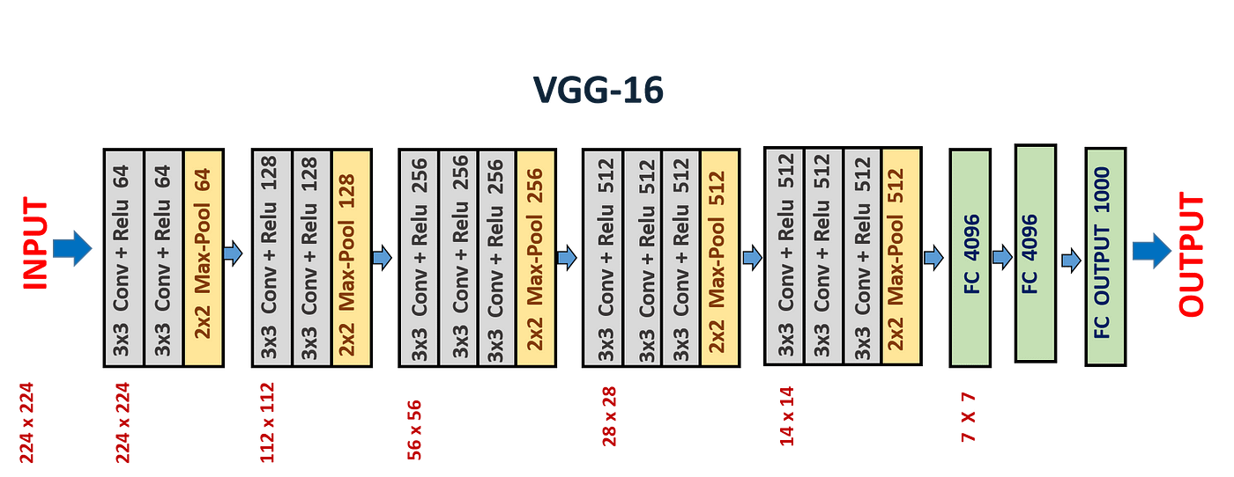

Figure 4. Model of VGG16

This approach consists of 3 totally linked levels and Thirteen convolutional layers. To decrease loss and enhance accuracy, Adam Optimization is being deployed. The Figure 6 displays the framework of VGG16 through clearly exhibiting the layers.

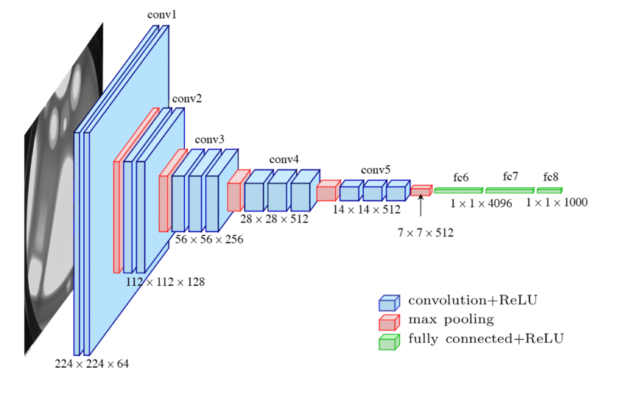

Figure 5. Network Architecture of VGG16

## Diagnosis using EfficientNet

The Efficient Network model has been suggested in Efficient Network: Rethinking This model Scaling over Convolutional Neural Networks, written by Mingxing Tan and Quoc V. Le. Efficient Networks are a family to image categorization models, which reach state-of-the-art accuracy, but having an order-of-magnitude fewer and quicker than earlier models. Efficient Network is a convolutional neural network ( CNN ) design and scaling technique which employs a compound coefficient in order to consistently increase all depth, broadness, and resolution parameters. The EfficientNet scalability method equally increases the width, depth, and resolution of the network using an assortment of preset scalability coefficients, and in contrast to traditional practice, where scales these variables freely. The idea behind the complicated scaling technique is the belief that larger pictures of input demand greater number of layers for the purpose to enlarge the networks receptive field as well as additional layers within order to pick out more fine-grained characteristics on the bigger canvas. In addition to the squeeze-and-excitation blocks of information, the basic EfficientNet-B0 network is constructed upon the MobileNetV2 inversion bottleneck blocks that remain.   
  
Efficient Networks transfer knowledge as well and attain the highest levels of precision on the CIFAR 100 (91.7%), Flower (98.8%), and 3 additional transferable learning data sets, with a few orders of magnitude less parameters. Figure 7 displays the computer network Infrastructure of EfficientNet.

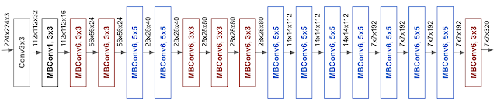

Figure 6. Network Architecture of EfficientNet

Google AI developed a collection of CNN models known as EfficientNet. These models are widely recognized for their precision and efficiency in utilizing computing resources. The design of EfficientNet is constructed using a compound scalability technique that ensures a harmonious balance between the network's dimension, width, and resolution. EfficientNet achieves a balanced compromise between the size of the model and its performance by adjusting these dimensions. The model has achieved state-of-the-art results on various picture tasks such as classification and underwent training on large datasets such as ImageNet.  
  
EfficientNet models, in general, demonstrate superior accuracy and efficiency compared to existing convolutional neural networks (CNNs). They achieve this by significantly lowering the amount of parameters and floating-point operations (FLOPS) by a factor of ten. As an illustration, in the high-accuracy range, our EfficientNet-B7 achieves an impressive 84 percent top-1 / 97.1% top-5 correctness on ImageNet, surpassing the preceding Gpipe by being 8.4 times smaller and 6.1 times quicker on CPU inference. When comparing our EfficientNet-B4 to the commonly used ResNet-50, we found that our model achieves equal FLOPS (floating point operations per second), but with a notable improvement in top-1 accuracy. While ResNet-50 achieves a top-1 accuracy of 76.3%, our EfficientNet-B4 achieves an accuracy of 82.6%, which is a significant increase of 6.3%.

## Diagnosis using Inceptionv3

Inception-v3 is a 48-layer deep convolutional neural network. The ImageNet database provides an untrained version of the neural network than was successfully trained on over one million photographs. The network that was previously trained can categorize pictures into a thousand distinct groups of objects, including many animals, a mouse, a keyboard, and a pencil. Consequently, the network has obtained comprehensive feature representations for many images. The size that the network's photo input approximately 299 × 299 pixels.   
  
Convolutional neural network Inception v3 was created as a module for Google Nets and is used to facilitate identifying objects and picture analysis. Google's Inception the Convolutional Neural which was first exhibited during the ImageNet Identification Competition, is in its final iteration. Inceptionv3 was built with the purpose of enabling greater network depth without permitting the number of variables to grow unmanageably large; it includes "under the twenty-five million variables," as opposed to sixty million parameters for AlexNet.  
  
Brainstorm aids in the categorization of things within the realm of computational vision, much how ImageNet can be considered as an archive of classed visual objects. Numerous applications have exploited the Inceptionv3 architecture, typically employing "pre-trained" information obtained from ImageNet. Leukemia studies are a single use for it in the realm of living sciences. After the widely circulated "'we have to go further' internet joke" after a sentence from the Christopher Nolan-directed Inception movie became viral, the initial title (Inception) was chosen in this fashion.   
  
The Inception Version 3 model is essentially the Inception Version 1 model modified and improved. Multiple strategies were applied by the model of Inception V3 to optimize the network's performance for improved model adaptability. It is more efficient. Compared with the Inception V 1 and V 2 designs, it has a larger network, but the speed is unaffected. It is simpler and cheaper to compute. As regularizers, it utilizes supplementary Classifiers. Figure 8 displays the Networked Model of Inceptionv3.

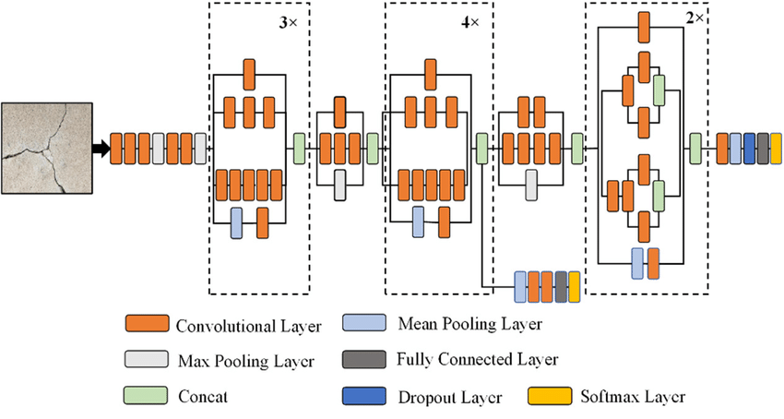

Figure 7. Network Architecture of Inceptionv3

# **IMPLEMENTATION**

In this paper, the efficacy of deep learning algorithms for detecting malignancy in MRI photographs is compared. Imported are Tensorflow is and many containers, namely Numpy, which Pandas, a MatplotLib, and Skimage. Among of the Tensor components utilized in the the VGG16 model implementation is Keras. Data was acquired via the image data generation tool and then fed into the model number VGG16. We use a batch with a capacity of 128 and an 10-epoch early termination. The Keras as package is additionally employed for implementing the Efficient Network and Inceptionv3 models. 1279 photographs are employed to test each model, 1027 pictures are employed for validating the creations, and 4098 images from magnetic resonance imaging are utilized in training. The loss can be reduced by utilizing the Adam optimizer. All of the images undergo processing and examined beforehand. Subsequently production of an approach, training utilizing those models, and analyzing the efficiency of the assessment is also done.   
  
Figure 9 displays an image with sixteen levels and an overview of the model generated with Keras. After ten repetitions, we achieved a prediction accuracy equal 0.8226, an accuracy for validation equal 0.8147, with a model loss represented in figure 12.

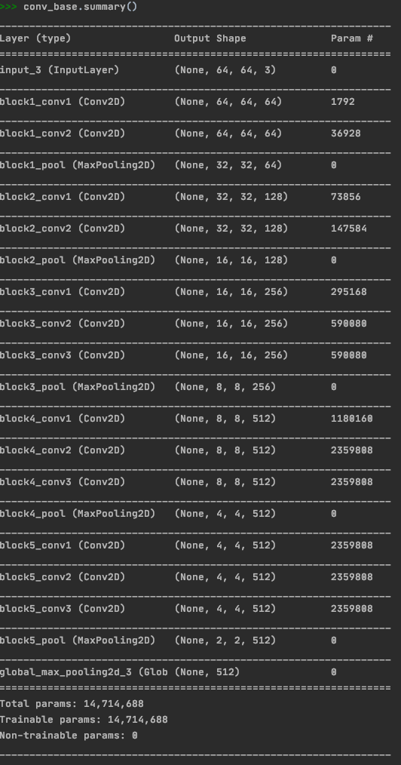

Figure 8. Model summary of VGG16

It would be good to look through the overview of the model built with Keras as for the purpose to acquire a greater comprehension of the system and its design. Each layer under the model is detailed in full in the summary of the model, indicating the total amount of variables and every layer's output form. On the initial set of data, a precision and 0.8226 (82.26%) was reached during ten rounds of training the algorithm. The percentage of successfully categorized samples within the initial set is indicated by this accuracy. In addition, a validation level of 0.8147 (81.47%) was achieved. The measure of validation correctness is the efficacy of the simulation model on a distinct validation set than was not used during training. It provides a calculation of the model's effectiveness on hypothetical data.   
  
A model is developed using 813 levels and an overview of the structure is presented beneath in figure 10. We went throughout 10 epochs and acquired a predictive accuracy of 0.9836, confidence level of 0.8709 and modeling loss which is displayed in figure 12.

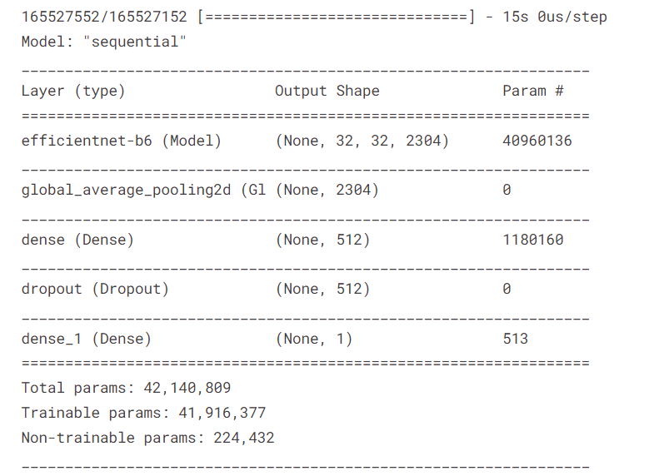

Figure 9. Model summary of EfficientNet

A model is developed with 48 levels and this overview of that model is presented beneath in figure 11. We having run throughout 10 epochs and received correctness of 0.9023, confirmation accuracy of 0.8867 with modeling loss which is displayed in figure 12.

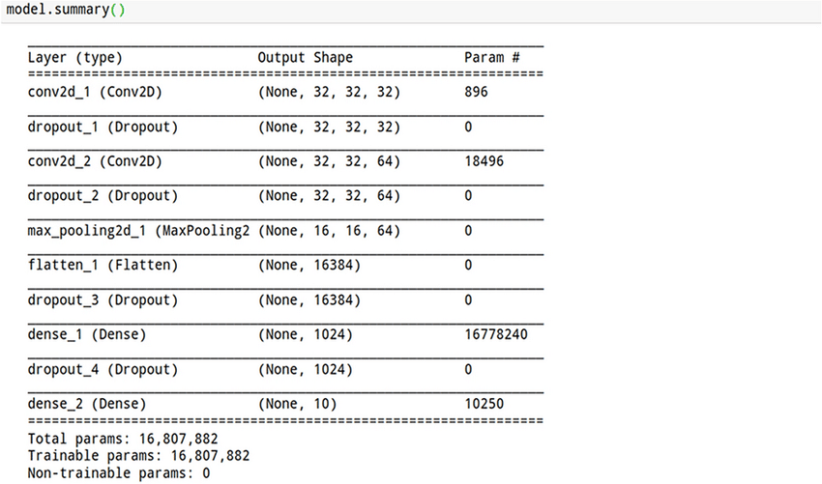

Figure 10. Model summary of Inception-v3

Figure 12 demonstrates about the learning efficiency and initialization loss for each of of the three designs, the VGG16 model EfficientNet and the latest version of In employed in our work. From this we can receive an unbiased assessment of the effectiveness of the models we used and this data is very vital and valuable for improving and improving the models that were previously trained for our application. The differences can be examined and appreciated clearly by examining the Table.1.

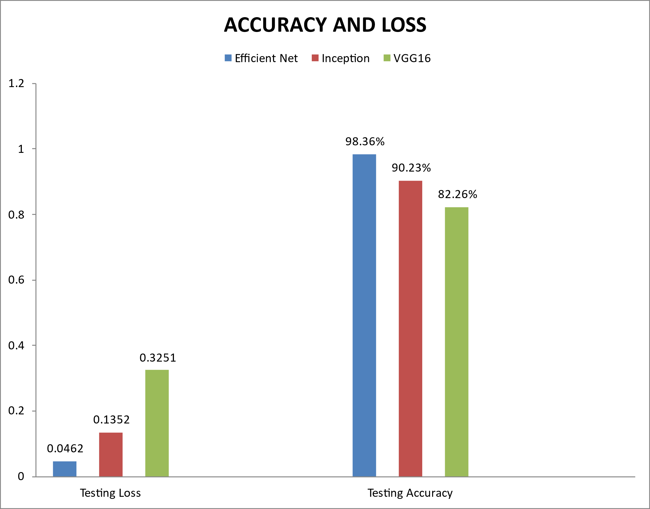

Figure 11. Model Accuracy and Loss of VGG16, EfficientNet and Inception-v3

1. COMPARISION TABLE BETWEEN 3 MODELS

| **Models** | Training Loss | Training Accuracy |
| --- | --- | --- |
| VGG-16 | 0.3251 | 82.26% |
| EfficientNet | 0.0462 | 98.36% |
| Inception-v3 | 0.1352 | 90.23% |

# **RESULTS**

The model leverages Google Laboratories as the implementation the surroundings, functions using a variety of pictures, and takes into consideration data form sources that are free to the public. The loss and accuracy figures for the VGG16 model Efficient Network, and Inceptionv3 are given in the graphs below. The preciseness of the Efficient Network model is greater compared to that for other models.   
  
The figure.13 & The figure.14 shows the precision and Losses of the the VGG-16 algorithm Model accordingly. The Figures fifteen and sixteen shows the precision and Losses of Efficient Network Model. The numbers 17 and 18 represent the accuracy and Losses of Inception, version 3, Model. From these data, Training and Testing Efficiency and Losses may be extrapolated effortlessly and the effectiveness of every one of the models in question can be appraised for its implementation and adjustments in our program.

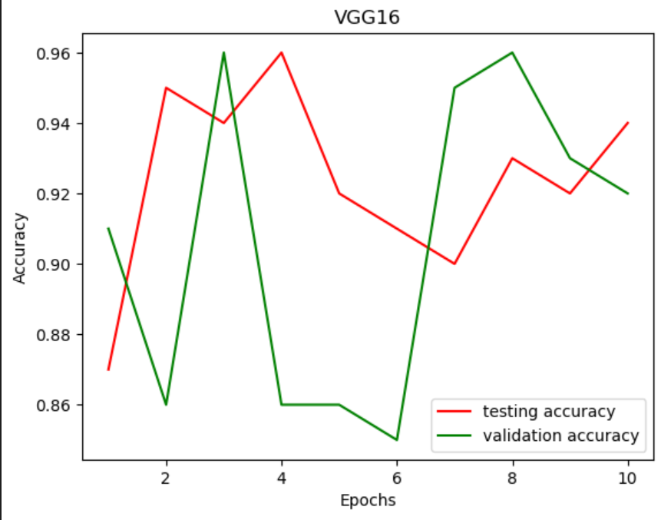

Figure 12. Model Accuracy of VGG16

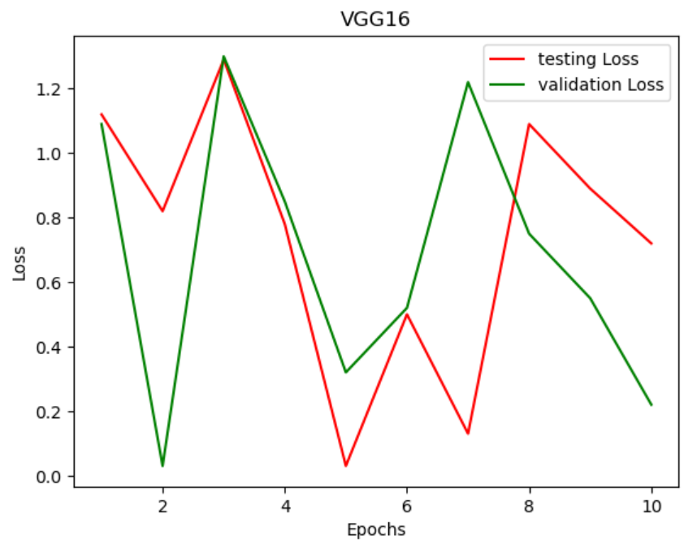

Figure 13. Model Loss of VGG16

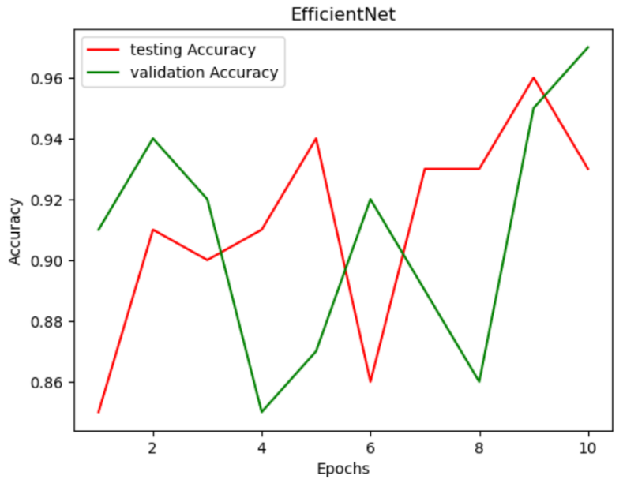

Figure 14. Model Accuracy of EfficientNet

Figure 15. Model Loss of EfficientNet

Figure 16. Model Accuracy of Inception-v3

Figure 17. Model Loss of Inception-v3

A confused matrices is a matrix utilised in analytics and machines learning to illustrate how effectively a classifications model is performing. By compared the predicted labeling with the actual labeling of a the data set, it allows us to analyze the efficacy as well as the precision of a the model's predictions. A complete examination of the algorithm's true favorable, actual negative, incorrect a yes, and erroneous negative predictions is presented in the matrix. The matrix of confusion is generally a matrix of squares, with the groups or categories within the data set forming the columns and rows. While the true labels appear along the rows of data, the labels that are anticipated are organized along the columns. The amount or percentage of the occurrences in every matrix cell that fit a certain prediction classification is shown. Simply brief, the confusion matrix gives a complete and intuitive depiction of a categorization model's performance. It enables for in-depth investigation of prediction mistakes and supports in adjusting and refining models to enhance their performance.  
  
A true-positive result (TP) = categorized as the +ve and material corresponds to the malignancy case ;   
True-negative result (TN) = categorized as −ve and evidence belongs to the typical case ;   
A false-positive (FP) = categorized is the +ve and evidence corresponds to the normal case ;   
False- Negative (FN) = categorized at −ve and evidence corresponds to a tumor case.   
  
Figures 18,20,21 displays the confused matrix for the following examples, the VGG16 model Efficient Network and Inception, version 3, correspondingly.

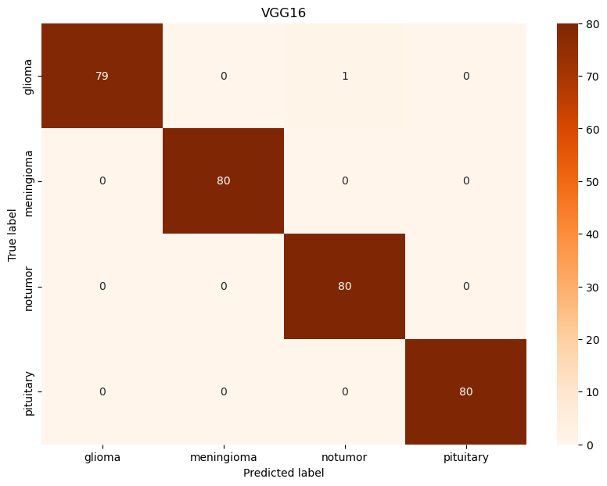

Figure 18. Confusion Matrix for VGG-16 Model

One can detect tendencies and specific groups where the framework stumbles or perform badly simply examining the mixture of false positive as well as inaccurate projections in the conflation matrix. The results of this research may influence subsequent feature development or model improvements.

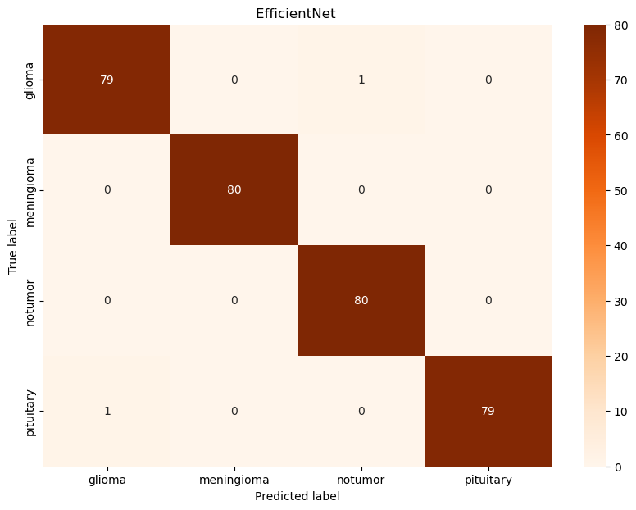

Figure 19. Confusion Matrix for EfficientNet Model

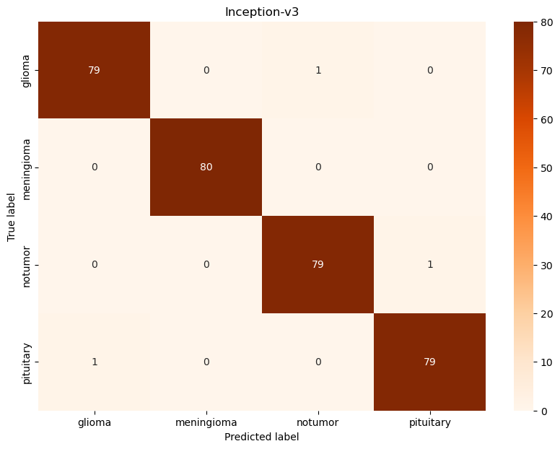

Figure 20. Confusion Matrix for Inception-v3 Model

Various metrics for performance, including precision, recall, precision, accuracy, and F1-score, are applied to assess the proposed model’s performance. These factors are analyzed using the disorientation matrix. For assessment of different methodologies, three significant measures were taken into account: recall, accuracy, and F1-score. All the assessment indicators for each of the proposed models were examined from the following table and are shown in Figure. 22.   
  
These parameters are computed using the conflation matrix, which is displayed as shown in Figures 19, 20 and 21. Hence, the different measurements can be defined as follows:

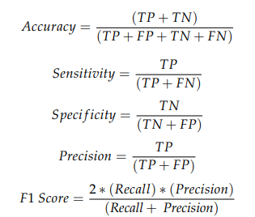

1. COMPARISION TABLE BETWEEN PERFORMANCE of OUR MODELS (CLASS SPECIFIC EVALUATION)

|  |  |  |  |  |
| --- | --- | --- | --- | --- |
| **Classes** | **Evaluation Metrics** | **EfficientNet** | **VGG16** | **Inception-v3** |
| Glioma | Precison | 1 | 1 | 0.98 |
| Recall | 0.98 | 0.98 | 0.98 |
| F1-Score | 0.99 | 0.98 | 0.96 |
| Meningioma | Precison | 0.99 | 1 | 0.97 |
| Recall | 1 | 0.99 | 1 |
| F1-Score | 1 | 0.97 | 0.99 |
| No tumor | Precison | 0.96 | 0.98 | 0.95 |
| Recall | 1 | 0.94 | 0.95 |
| F1-Score | 0.98 | 0.95 | 0.95 |
| pituitary | Precison | 1 | 0.9 | 0.98 |
| Recall | 0.97 | 0.94 | 0.94 |
| F1-Score | 0.98 | 0.98 | 0.96 |

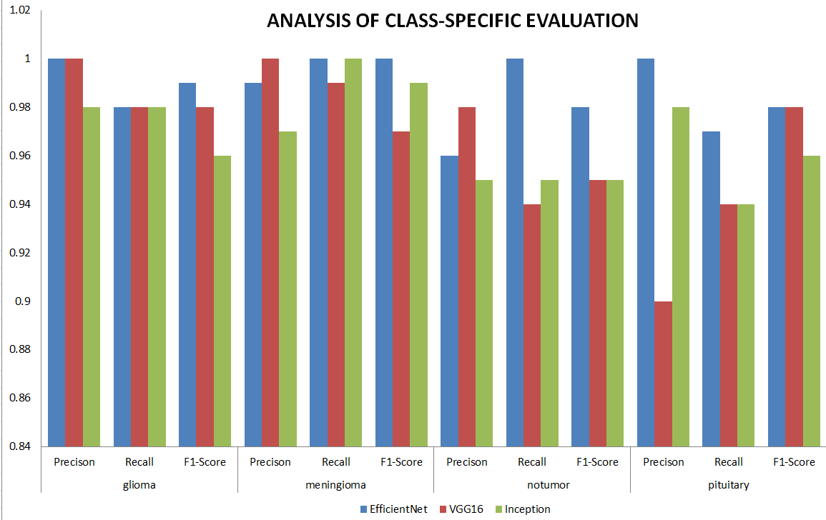

Figure 21. Analysis: Class-Specific Evaluation of Brain Tumor using Pretrained Models

# **CONCLUSION AND FUTURESCOPE**

In the present research, we effectively developed three separate neural networks for categorizing brains tumors: a Convolutional Neural Network, also known as (CNN), a the VGG16 model an Efficient Network, and an Inception. We trained and assessed these mathematical models using an assortment identifying brain magnetic resonance imaging photographs, with excellent outcomes in terms both precision and loss metrics. The models that were previously trained, such as the VGG16 model Efficient Network, and Inception, a as well as the one trained by CNN, have all proven the capacity to understand and differentiate among "normal" versus "Tumor" categories using head MRI data. Transfer learning, which leverages models that have been trained previously, performs more effectively compared to an CNN framework that was constructed from scratch since it enables us apply the characteristics we have learned from hugedatasets.   
  
We discovered that Efficient Network and Inception surpassed the VGG16 model with regard to of precision as well as loss while evaluating the efficiency of each of the models. This reveals show the additional intricate structures of Efficient Network, with a success rate for 98.36%, & Inception-v3, having an accuracy for 90.23%, make it possible to identify the additional features and patterns necessary for identifying the type of brain tumor. After comprehensive research and comparison, we observed that Efficient Network and Inception exceeded the VGG16 model with a precision of 82.26%, gaining higher accuracy and reduced loss. This underlines how crucial the creation of models is in capturing complicated factors that have been crucial for determining the kind of brain tumor. The increasingly sophisticated designs for architecture of Efficient Network and Inception model let computers effectively separate and integrate intricate structures from magnetic resonance imaging (MRI) data, increasing classification performance.  
  
Upcoming studies and developments offer a lot more possibilities. By customizing them to the characteristics of information for brain tumors, models that have already been trained can be made more successful at capturing factors connected to the condition. Innovative data augmentation strategies and solutions for category imbalance concerns can increase model robustness and generalization capabilities. The comprehensible nature and explicability that accompany the algorithms' forecasts are also stressed, which helps in raising healthcare specialists' acceptance of them. The selection procedure underlying the algorithms can be evaluated and displayed using Grad-CAM technology or the SHAP algorithm values, which can boost comprehension or validation by identifying the parts of the brain in the magnetic resonance imaging (MRI) scans that are critical for categorization. Furthermore, broadening the classification project's ambit to embrace multiple categories can result in the release of greater amounts of diagnostic information, permitting a more precise categorization of brain tumor into discrete phases or subtypes. It may be simpler to design tailored treatment plans and remedies for distinct patients as aresult.   
  
In the future, practitioners may find the recommended model beneficial in determining a fast identification of brain tumor. This strategy can be implemented into an online platform to enhance its application.

##### **References**

1. Aly, M. and Alotaibi, A.S. (2023) ‘EMU-NET: Automatic brain tumor segmentation and classification using efficient modified U-Net’, *Computers, Materials &amp; Continua*, 77(1), pp. 557–582. doi:10.32604/cmc.2023.042493.
2. Gajula, S. and Rajesh, V. (2023) ‘Performance analysis of classification and detection of brain tumor MRI images using Resnet50 deep residual U-Net’, *Journal of Iranian Medical Council* [Preprint]. doi:10.18502/jimc.v6i1.11848.
3. Mahajan, N. and Chavan, H. (2023) ‘MRI images based brain tumor detection using CNN for Multiclass Classification’, *2023 3rd Asian Conference on Innovation in Technology (ASIANCON)* [Preprint]. doi:10.1109/asiancon58793.2023.10270492.
4. Mohan, C.K. and Samudrala, S. (2023a) ‘MRI brain tumor detection and classification using U-NET CNN’, *2023 International Conference on Data Science and Network Security (ICDSNS)* [Preprint]. doi:10.1109/icdsns58469.2023.10245128.
5. Mohan, C.K. and Samudrala, S. (2023b) ‘MRI brain tumor detection and classification using U-NET CNN’, *2023 International Conference on Data Science and Network Security (ICDSNS)* [Preprint]. doi:10.1109/icdsns58469.2023.10245128.
6. Nayak, D.R. *et al.* (2022) ‘Brain tumor classification using dense efficient-net’, *Axioms*, 11(1), p. 34. doi:10.3390/axioms11010034.
7. Pravallika, Ch.R. and Baskar, R. (2022) ‘Image processing based brain tumor classification using VGG16 compared with SVM to improve accuracy’, *2022 11th International Conference on System Modeling &amp; Advancement in Research Trends (SMART)* [Preprint]. doi:10.1109/smart55829.2022.10047671.
8. Shanjida, S., Islam, Md.S. and Mohiuddin, M. (2022) ‘MRI-image based brain tumor detection and classification using CNN-KNN’, *2022 IEEE IAS Global Conference on Emerging Technologies (GlobConET)* [Preprint]. doi:10.1109/globconet53749.2022.9872168.
9. Soumik, Mohd.F. and Hossain, Md.A. (2020a) ‘Brain Tumor Classification with Inception Network based Deep Learning Model using transfer learning’, *2020 IEEE Region 10 Symposium (TENSYMP)* [Preprint]. doi:10.1109/tensymp50017.2020.9230618.
10. Soumik, Mohd.F. and Hossain, Md.A. (2020b) ‘Brain Tumor Classification with Inception Network based Deep Learning Model using transfer learning’, *2020 IEEE Region 10 Symposium (TENSYMP)* [Preprint]. doi:10.1109/tensymp50017.2020.9230618.
11. Sowrirajan, S.R., Balasubramanian, S. and Raj, R.S. (2023) ‘MRI brain tumor classification using a hybrid VGG16-nade model’, *Brazilian Archives of Biology and Technology*, 66. doi:10.1590/1678-4324-2023220071.
12. Yahya Rbat, J., Aljobouri, H.K. and Hasan, A.M. (2022) ‘MRI brain tumor classification using robust convolutional neural network CNN approach’, *2022 Iraqi International Conference on Communication and Information Technologies (IICCIT)* [Preprint]. doi:10.1109/iiccit55816.2022.10009913.
13. Asodekar, B. and Gore, Prof.S. (2019) ‘Brain tumor classification using shape analysis of MRI images’, *SSRN Electronic Journal* [Preprint]. doi:10.2139/ssrn.3425335.
14. C., N. (2020) ‘Chaotic biogeography rider-based neural network for brain tumor classification using MRI images’, *Journal of Advanced Research in Dynamical and Control Systems*, 12(SP3), pp. 701–719. doi:10.5373/jardcs/v12sp3/20201309.
15. Montaha, S. *et al.* (2022) ‘Timedistributed-CNN-LSTM: A hybrid approach combining CNN and LSTM to classify brain tumor on 3D MRI scans performing ablation study’, *IEEE Access*, 10, pp. 60039–60059. doi:10.1109/access.2022.3179577.
16. T S, C. *et al.* (2023) ‘Automated identification and localization of brain tumor in MRI using U-Net segmentation and CNN-LSTM classification’, *International Journal on Recent and Innovation Trends in Computing and Communication*, 11(10s), pp. 637–644. doi:10.17762/ijritcc.v11i10s.7703.
17. Özkaraca, O. *et al.* (2023) ‘Multiple brain tumor classification with dense CNN architecture using brain MRI images’, *Life*, 13(2), p. 349. doi:10.3390/life13020349.
18. Jindal, S.K. *et al.* (2022) ‘Deep learning-based brain malignant neoplasm classification using MRI image segmentation assisted by bias field correction and histogram equalization’, *Brain Tumor MRI Image Segmentation Using Deep Learning Techniques*, pp. 135–161. doi:10.1016/b978-0-323-91171-9.00008-9.
19. Lakhanpal, A. (2022) ‘Brain tumor segmentation,classification and detection using MRI images: A Review’, *SSRN Electronic Journal* [Preprint]. doi:10.2139/ssrn.4041720.
20. Tummala, S. (2022) Brain tumor classification from MRI using Vision Transformers ensembling [Preprint]. doi:10.21203/rs.3.rs-1593662/v1.